Abstract
Background:
Bacterial vaginosis (BV) remains a highly recurrent condition despite standard therapy with metronidazole (MTZ) or clindamycin. Most studies report cure rates ranging from 40–60%, with recurrence rates up to 60% within months. Whether sequential MTZ followed by clindamycin improves short-term clinical outcomes in African populations remains unclear. BV increases the risk of HIV acquisition in women and causes long-term reproductive complications in women of reproductive potential.
Methods:
In this prospective cohort study conducted at the CAPRISA eThekwini Clinical Research Site, 231 women were screened, and 100 BV-positive, STI-negative, non-pregnant women aged 18 to 45 years, with no antimicrobial exposure within 7 days prior to screening, were enrolled. All received oral MTZ 400 mg twice daily for 7 days at enrolment. BV status was assessed at Days 8, 16, and 24 using Nugent and/or Amsel criteria. Participants with persistent BV at Day 8 were treated with intravaginal clindamycin 5% for 7 nights. Outcomes included BV persistence, clearance, and early recurrence by Nugent Score.
Results:
After MTZ treatment, 80% (n=80) remained BV-positive and only 20% (n=20) achieved clearance. Following clindamycin, BV persistence remained high (74%, n=74), with modest additional clearance (15%, n=15) and 10% (n=10) early recurrence. By Day 24, 70% (n=100) remained BV-positive, sustained clearance was unchanged (20%, n=20), recurrence was 7% (n=7) and 3 participants were lost-to-follow-up at day 24. Enrolled women had higher baseline vaginal pH, more frequent positive whiff tests, and higher prevalence of BV-related symptoms compared with screen-outs.
Conclusion:
Sequential MTZ and clindamycin treatment resulted in low BV clearance and high persistence, with more than half of women remaining BV-positive by Day 24. These findings highlight the limited effectiveness of standard regimens in this setting and underscore the urgent need for improved BV therapies and microbiota-informed interventions.

Introduction
Bacterial vaginosis (BV) is caused by overgrowth of the normal vaginal flora, causing dysbiosis of the vaginal microbiome. This imbalance within the vaginal microbiome has been found to be the commonest cause of inflammation within the female genital tract(1, 2). BV is the most common cause of vaginal discharge among reproductive-age women globally and is associated with increased HIV acquisition, adverse pregnancy outcomes, and upper genital tract infections(3). STI testing is not standard practice at public healthcare level in South Africa and current national guidelines for the treatment of sexually transmitted infections recommend a triple therapy regimen consisting of 1g of azithromycin orally, 250mg of ceftriaxone intramuscular injection, and 2g of metronidazole orally as a single dose(4). This approach is syndromic rather than pathogen directed and relies on clinical assessment of the presence or absence of a vaginal discharge in women(5). Targeted treatment guidelines recommend oral metronidazole or intravaginal clindamycin, achieve initial cure rates of only 40–60%, and up to 60% of women experience recurrence within 3–6 months after therapy(6-8). A systematic review and meta-analysis of the BV among women of reproductive age conducted by the WHO indicated a global prevalence of 23–29% (9). A recent surveillance report in South Africa found that 58.2 % of females presenting to healthcare facilities with vaginal discharge syndrome tested positive for bacterial vaginosis alone or with an intercurrent sexually transmitted infection(10).
Factors linked to treatment failure include both socio-behavioural factors (education, sexual activity, socioeconomic status) and biological factors (persistent anaerobic biofilms, antimicrobial resistance, and failure to restore protective Lactobacillus species)(11). While the use of metronidazole and clindamycin as treatment interventions for BV have been described individually, data on sequential treatment (metronidazole followed by clindamycin in persisters) remain sparse, especially from African settings where BV prevalence is high and recurrence may be driven by complex host-microbe interactions (12, 13).
BV in women of reproductive age is significantly influenced by a range of socio-behavioural variables that alter the vaginal microbiota and encourage a transition from Lactobacillus-dominant communities to anaerobic overgrowth(14). High-risk sexual behaviours, including multiple sexual partners, new partners, and inconsistent condom use, have been consistently associated with increased BV recurrence, likely due to the exchange of genital microbiota and exposure to semen, which transiently raises vaginal pH and destabilises microbial homeostasis(15, 16). Treatment for male partners is still debatable, and untreated partners may contribute to persistence of vaginal dysbiosis or reinfection(17). Personal hygiene practices, such as douching and intravaginal washing practices, can directly modify the vaginal environment and deplete beneficial Lactobacillus species, thereby significantly increasing the risk of recurrence(18). Socioeconomic factors also play a role: restricted access to healthcare, lower health literacy, and structural gender inequalities can delay diagnosis, hamper adherence to treatment, and perpetuate behavioural hazards(19). Socioeconomic factors also play a role: restricted access to healthcare, lower health literacy, and structural gender inequalities can delay diagnosis, hamper adherence to treatment, and perpetuate behavioural hazards(20).
Of the biological factors influencing BV recurrence and treatment failure, the development of dense, polymicrobial anaerobic biofilms, mainly made of Gardnerella vaginalis with embedded taxa like Atopobium vaginae, is a major factor(21). The biofilms adhere firmly to the vaginal epithelium and shield pathogenic communities from host immunity and antimicrobial penetration(22). They function as microbial reservoirs, allowing rapid recolonisation following treatment and contributing to high recurrence rates(23). Treatment failure is worsened by antimicrobial resistance and published literature on BV-associated organisms, such as G. vaginalis and A. vaginae, indicate that these organisms are less susceptible to metronidazole and clindamycin(12). This resistance is mediated by mechanisms like nitroreductase gene variation through diminished production of oxygen sensitive nitroreductases and biofilm-associated tolerance(24, 25). Additionally, many women fail to re-establish a Lactobacillus-dominant microbiota, particularly Lactobacillus crispatus which is associated with stability and low recurrence, after antibiotic therapy(26). Instead, antibiotic therapy results in transient suppression of anaerobes without the long-term restoration of protective lactic-acid–producing species, thus predisposing the vaginal environment to rapid re-emergence of BV-associated populations(27). These interlocking biological variables stress the complexity of recurrent BV and highlight the need for treatments targeting biofilm destruction, antibiotic resistance, and persistent Lactobacillus recolonisation(28, 29).
The CAPRISA 098 (CAP098) study was designed to evaluate clinical outcomes of sequential BV therapy among South African women using strict diagnostic criteria and short-interval follow-up. Here, we report clinical BV clearance, persistence, and early recurrence through Day 24 after sequential oral metronidazole followed by intravaginal clindamycin among non-pregnant, STI-negative women with BV.
Methods
Study Design and Setting
This study was conducted as a prospective interventional cohort study conducted at the CAPRISA eThekwini Clinical Research Site in Durban, South Africa, adjacent to the Prince Cyril Zulu Communicable Disease Centre.
to evaluate whether point-of-care testing and immediate treatment of confirmed BV, in the absence of STIs, with 400 mg MDZ twice per day for 7 days reduces the rates of recurrent or persistent BV in South African women aged 18 to 45 years who were either HIV positive or negative. The study included 4 visits; screening/enrolment, day 8, day 16, and day 24. Participants who are enrolled received treatment with Metronidazole 400mg orally twice per day for 7 days. Participants who showed BV persistence at day 8 were then treated with clindamycin 2%.

Participant Screening and Eligibility
Women between the age of 18 to 45 years, of reproductive potential, were recruited and enrolled by the Centre for the AIDS Programme of Research In South Africa (CAPRISA) at the eThekwini Clinical Research Site (ECRS) in KwaZulu-Natal, South Africa. The research site is conveniently situated in Warwick triangle which is a busy transportation and commercial hub in a metropolitan region of Durban. Participants were recruited from the local public-access municipal clinics which offer HIV, TB and STI services, universities or the general public. Screening and enrolment was conducted between October 2024 - September2025 A total of 231 women were screened. Inclusion criteria were:
- BV-positive by Nugent and/or Amsel criteria
- Negative for Chlamydia, gonorrhoea, trichomoniasis, symptomatic candida
- Non-pregnant
- No antibiotic use within the preceding 7 days
- Age 18–45
- Able to provide informed consent
- Exclusion criteria followed the CAP098 protocol and clinical opinion of the investigator.
Enrollment and Treatment Procedures
Women diagnosed with BV at screening were enrolled (n=100) and immediately treated with oral metronidazole 400 mg twice daily for 7 days, per protocol. Follow-up visits occurred at Day 8, Day 16, and Day 24. Women who remained BV-positive at Day 8 were provided intravaginal clindamycin 2% cream once daily for 7 nights. BV testing was repeated at days 16 and 24, where treatment was provided as per the national standard-of-care. Participants performed daily self-swabbing, 24 hours after initiating metronidazole at enrolment, up to day 16 post-enrolment.
BV Diagnosis and Definitions
The diagnosis of BV is based on clinical findings with Nugent score, or Nugent score and Amsel criteria combined. Nugent score is calculated by assessing for the presence of large Gram-positive rods (Lactobacillus morphotypes; decrease in Lactobacillus scored as 0 to 4), small Gram-variable rods (Gardnerella vaginalis morphotypes; scored as 0 to 4), and curved Gram-variable rods (Mobiluncus spp. morphotypes; scored as 0 to 2). A score of 4 to 6 in symptomatic subjects and a score of 7 to 10 in asymptomatic persons is consistent with BV without culture.
At least three of the following four characteristics are required to be present by Amsel criteria: a uniform, thin, whitish, and yellow discharge, wet mount microscopy of clue cells , a vaginal fluid pH of > 4.5 when placing the discharge on litmus paper, presence of fishy odour after adding 10% potassium hydroxide (KOH) solution to wet mount - commonly known as “whiff test.”
BV clearance was determined by Nugent scoring of 0 – 3 or Amsel criteria of < than three factors. BV persistence was defined as a Nugent score of 4 – 10, with or without symptoms or Amsel criteria of ≥3 at follow-up. BV recurrence was defined as BV clearance at prior visit followed by BV at next visit.
Statistical Analysis
Study data was entered into a secured REDCap database as live data entry. All records were single entry and underwent a two-tiered quality control. Data was then analyzed using R version 4.5.3.
We calculated proportions of participants with persistence, clearance, and recurrence at each study timepoint. Baseline characteristics of enrolled participants were described to contextualize clinical severity.

Results
Enrollment and Follow-up
Of 231 women screened, 100 were enrolled and 97 completed all follow-up evaluations. Three participants were lost-to-follow-up by day-24 of the study. All participants received oral metronidazole at enrolment (Day 0) and had BV status was assessed at Days 8, 16, and 24.
Baseline Characteristics

A total of 100 participants were enrolled in the CAP098 study, all of whom were female (100%) and identified as African (100%), indicating a demographically homogeneous cohort.
The mean age of participants was 30 years (SD = 6), with a median age of 29 years (IQR: 25–35), reflecting a predominantly young adult population.
Within this cohort, 65 women had completed secondary school (65%), followed by 32 (32%) who had attained tertiary education. A small proportion 3 (3%) reported only primary school education.
The most common source of income was obtained from social grants (41%), followed by family support (29%). Only 11% and 10% of participants reported being employed part-time and self-employed, respectively. Notably, 4% of participants reported having no income. Full-time employment was reported by only 3% of participants, while 2% indicated financial support from a partner.
Women living with HIV attributed to 19% of this cohort, while 81% were HIV negative.

Table 1. Sociodemographic factors and personal history of women enrolled into the CAP098 study:
Sociodemographic factors | N | Enrolled  N = 100, n (%)¹ | Overall  N = 100, n (%)¹
Gender: Female | 100 | 100 (100%) | 100 (100%)
Ethnicity: African | 100 | 100 (100%) | 100 (100%)
Age (in years) | 100
Mean (SD) |  | 30 (6) | 30 (6)
Median (IQR) |  | 29 (25 - 35) | 29 (25 -35)
Min, Max |  | 18, 44 | 18, 44
Highest Level of Education | 100
Secondary school |  | 65 (65%) | 65 (65%)
Tertiary education |  | 32 (32%) | 32 (32%)
Primary school |  | 3 (3.0%) | 3 (3.0%)
No schooling |  | 0 (0%) | 0 (0%)
Other |  | 0 (0%) | 0 (0%)
Sources of Income | 100
Social grants |  | 41 (41%) | 41 (41%)
Family support |  | 29 (29%) | 29 (29%)
Employed part-time |  | 11 (11%) | 11 (11%)
Self employed |  | 10 (10%) | 10 (10%)
No income |  | 4 (4.0%) | 4 (4.0%)
Employed full-time |  | 3 (3.0%) | 3 (3.0%)
Partner provides |  | 2 (2.0%) | 2 (2.0%)
Sexual and Pregnancy history
Lifetime number of sexual partners
Number of partners in 1 month prior to enrolment
Nulliparous women
Primipara women
Multiparous women
Number of miscarriages
Number of live births
Products used during menstruation
Sanitary pads
Tampons
A reusable cloth
Reusable period underwear
Menstrual cups
Tissues
HIV status | 100
Positive |  | 19 (19%) | 19 (19%)
Negative |  | 81 (81%) | 81 (81%)

Table 2. Clinical signs and symptoms of women with BV
Clinical finding | Total number |  | Percentage (%)  n = 100
Abnormal vaginal or cervical discharge |  | 72 |  | 72 %
Vulvar lesions |  | 02 |  | 2 %
Vaginal wall erythema |  | 04 |  | 4 %
Cervical lesions (ulceration/ blister) |  | 02 |  | 2 %
Cervical plaques |  | 07 |  | 7 %
Cervical erythema |  | 06 |  | 6 %
Weight (in kilograms, kg)
Mean (SD) |  | 82 (20) |  | -
Median (IQR) |  | 82 (66 – 94) |  | -
Not Applicable/Missing |  |  |  | 1

Among women diagnosed with bacterial vaginosis (BV) (n = 100), the predominant clinical presentation was abnormal vaginal or cervical discharge, reported in 72% of participants. In contrast, other clinical signs were relatively infrequent. Cervical plaques were observed in 7% of women, while cervical erythema was noted in 6%. Vaginal wall erythema was present in 4% of cases. Lesions were uncommon, with vulvar lesions and cervical ulceration or blistering reported in only 2% of participants. The mean weight amongst this group of women was 82kg (SD = 20) and median 82kg (IQR: 66 – 94).
Overall, the clinical profile was dominated by abnormal discharge, with minimal evidence of inflammatory or ulcerative pathology. This pattern is consistent with the typical presentation of BV, which is characterised by alterations in vaginal flora rather than overt mucosal inflammation.
Table 3. Nugent score and microscopy at Day 0, 8, 16 and 24

Nugent score | 100
Mean (SD) |  | 6.44 (1.43) | 6.44 (1.43)
Median (IQR) |  | 7.00 (5 - 7) | 7.00 (5.00, 7.00)
Min, Max |  | 4.00, 9.00 | 4.00, 9.00
BV by Nugent Score | 100
Clinical BV |  | 58 (58%) | 58 (58%)
Sub-clinical BV |  | 42 (42%) | 42 (42%)
Nugent microscopy | 100 | 100 (100%) | 100 (100%)
Lactobacillus | 100
[Day 0] |  | 7 (7.0%) | 7 (7.0%)
[Day 8] |  | 31 (31%) | 31 (31%)
[Day 16] |  | 44 (44%) | 44 (44%)
[Day 24] |  | 18 (18%) | 18 (18%)
Gardenella | 100
[Day 0] |  | 3 (3.0%) | 3 (3.0%)
[Day 8] |  | 26 (26%) | 26 (26%)
[Day 16] |  | 33 (33%) | 33 (33%)
[Day 24] |  | 38 (38%) | 38 (38%)
Mobiluncus | 100
[Day 0] |  | 43 (43%) | 43 (43%)
[Day 8] |  | 49 (49%) | 49 (49%)
[Da16] |  | 8 (8.0%) | 8 (8.0%)
3
4

Table 3 presents longitudinal microbiological findings for bacterial vaginosis (BV) assessed by Nugent scoring across study visits (Day 0, 8, 16, and 24).
The study population (N=100) shows a mean Nugent score of 6.44 (SD = 1.43) and a median of 7.00 (IQR 5-7). A score of 7 or higher is the clinical threshold for Bacterial Vaginosis (BV). Clinical BV was found amongst 58% of the participants. While 42% showed subclinical BV within this specific group.
The three key morphotypes of bacterial vaginosis are described over 24 days.
There is a significant spike in Lactobacillus detection from Day 0 (7%) to Day 16 (44%), followed by a sharp decline by Day 24 (18%). This low baseline on Day 0 confirms a state of dysbiosis. The increase by Day 16 might suggest a transient recovery or a response to an intervention, but the subsequent drop by Day 24 indicates that the healthy flora failed to remain dominant.

Gardnerella species, which is considered indicative of BV, shows a steady and aggressive increase throughout the study, moving from 3% on Day 0 to 38% by Day 24. Unlike the fluctuating Lactobacillus, Gardnerella shows a consistent upward trajectory. By Day 24, it is the most prevalent morphotype, indicating a worsening dysbiotic state.
Mobiluncus is found to have high prevalence initially, 43% on Day 0 and 49% on Day 8 followed by a massive crash to 8% by Day 16.
Mobiluncus is often associated with higher-grade BV and malodour. The sudden drop between Day 8 and Day 16 can possibly be attributed to Gardnerella presence, or that the environment shifted to favour different anaerobes.

Table 4. Amsel score at Day 0, 8, 16 and 24
Variable | Category | Proportions
Day 8
Vaginal pH | >4.5 | 58
Vaginal pH | ≤4.5 | 42
clue | Positive | 1
vaginal | Present | 27
whiff | Positive | 22
Day 16
Vaginal pH | >4.5 | 81
Vaginal pH | ≤4.5 | 18
clue | Positive | 0
vaginal | Present | 19
whiff | Positive | 10
Day 24
Vaginal pH | >4.5 | 71
Vaginal pH | ≤4.5 | 27
clue | Positive | 0
vaginal | Present | 23
whiff | Positive | 11

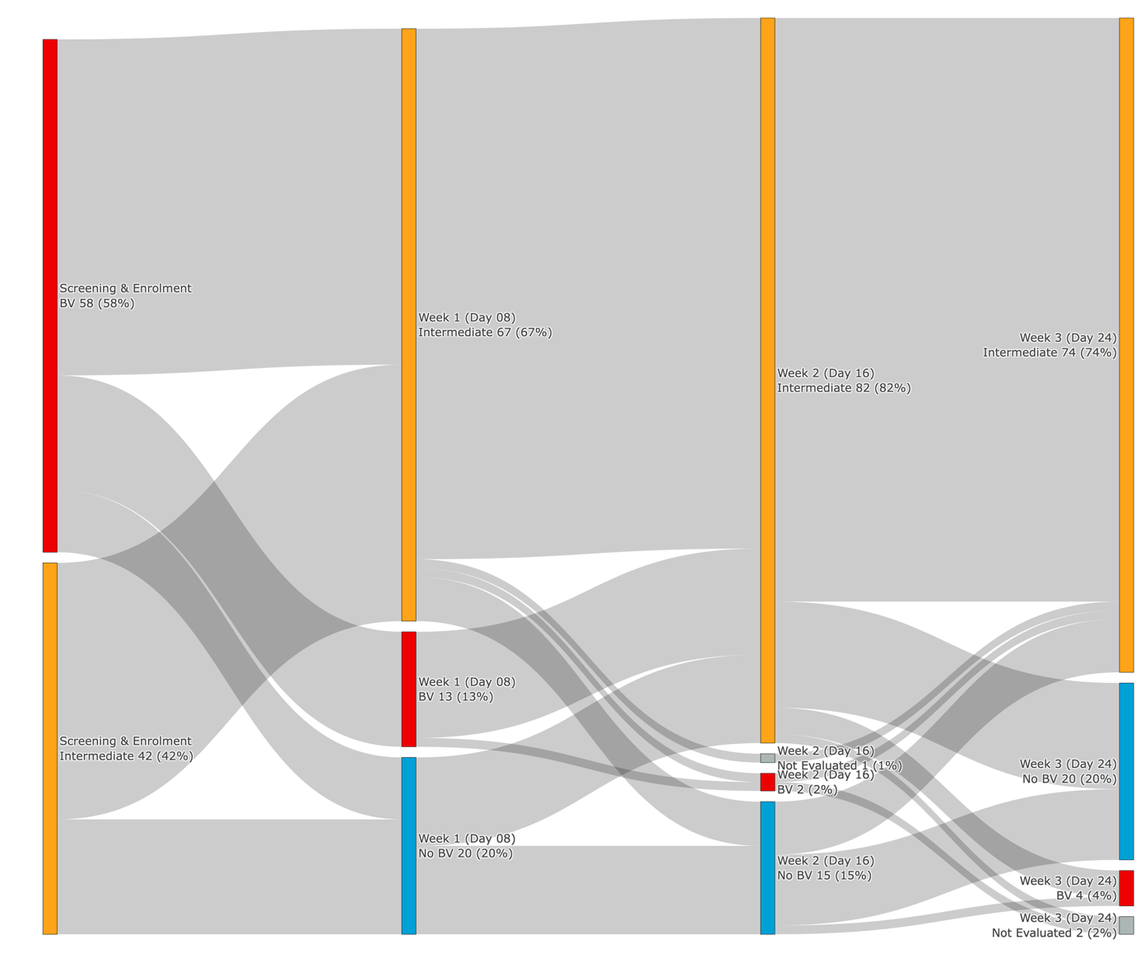
Figure 1: Longitudinal BV status trajectories of all 100 participants across four study visits.
The dominant pattern over the study period was a progressive shift toward intermediate BV status (Nugent score 4 – 6). By Week 1 (Day 8), 67% of participants were classified as intermediate BV and 20% had cleared BV ( no BV, Nugent score 0-3) , which can be considered as an early treatment response signal. BV (Nugent score 7 – 10) was found in 13% of women at day 8. By Week 2 (Day 16), the intermediate BV category expanded further to 82%, with 15% at No BV and only 2% with BV. By Week 3 (Day 24), 74% remained intermediate, 20% achieved No BV clearance, and 4% showed recurrence (BV), while 2% were not evaluated.
BV Outcome | Count | Percentage
Day 8
Clearance | 20 | 20%
Persistence | 80 | 80%
Day 16
Clearance | 15 | 15%
Persistence | 74 | 74%
Recurrence | 10 | 10%
NA | 1 | 1%
Day 24
Clearance | 20 | 20%
Persistence | 70 | 70%
Recurrence | 7 | 7%
NA | 3 | 3%

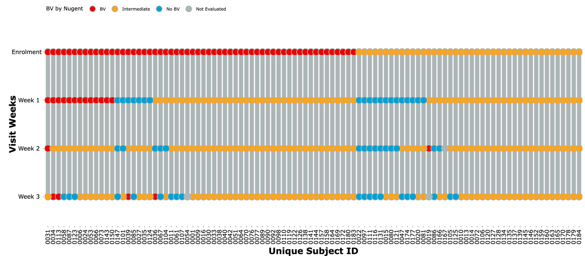
Figure 2: Individual-level resolution of BV dynamics across the study.
At enrolment, there is a clear bipartition of the cohort into BV (red, left cluster) and intermediate BV (orange, right cluster), consistent with the Nugent-based eligibility criteria.
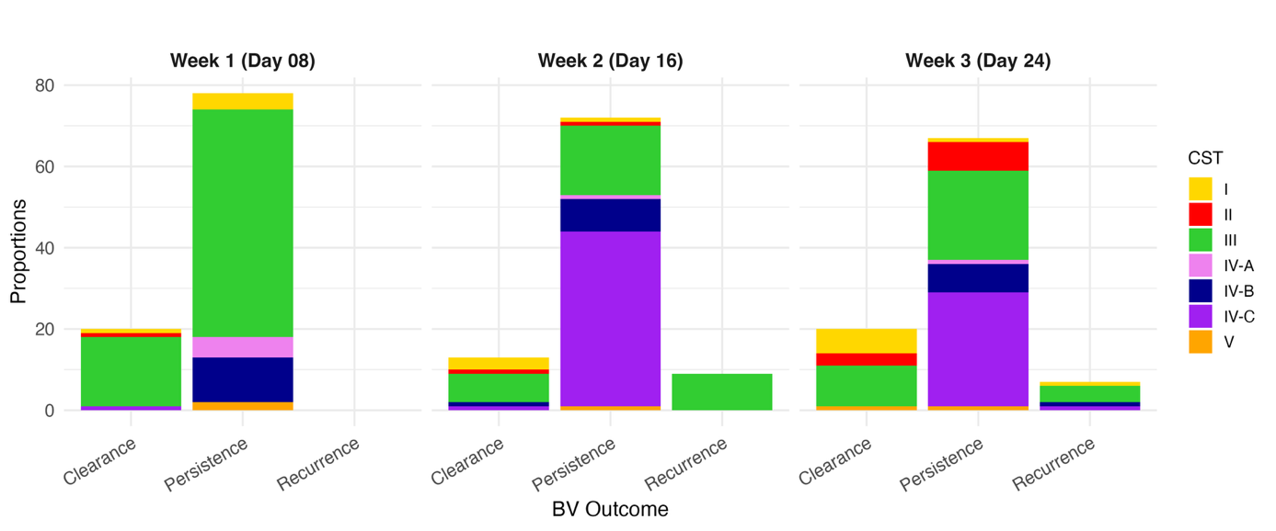
By Week 1, several participants in the BV group have shifted to No BV (blue dots), representing early responders to treatment. The majority transitioned to intermediate BV (orange). By Weeks 2 and 3, No BV (blue) responses appear distributed across the cohort, but most participants remain in the intermediate category throughout, reflecting the aggregate patterns in Figure 1.

Figure 3: BV clinical outcomes linked to underlying vaginal microbiome composition (CST) at each follow-up visit

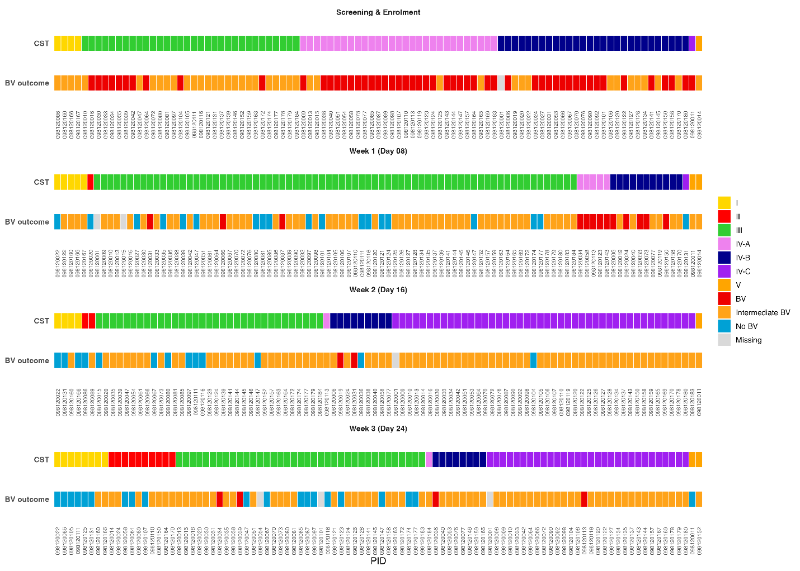
Figure 4: Community State Type (CST) pattern across all visits over 24 days.
At all three visits, CST III (Lactobacillus iners-dominant, green) is the predominant type among participants who achieved BV clearance. CST I (gold) is a minor but present component of the clearance group, particularly at Week 1. The persistence group is dominated by CST IV-C (purple) and CST III (green) across all visits. The recurrence group is small but contains a mix of CST III, IV-B, and IV-C at Week 2, and shows more CST diversity by Week 3.
CST III is the most common state after baseline, especially at Week 1 and Week 3. BV outcome is dominated by Intermediate BV after baseline, even when CST looks more Lactobacillus-dominant. IV-B and IV-C tend to sit near worse BV outcomes, but the mapping is not one-to-one.
Discussion
Bacterial vaginosis (BV) is a serious reproductive health challenge among women of reproductive age in South Africa, where prevalence estimates routinely exceed those reported in high-income settings. Cross-sectional and cohort studies from KwaZulu-Natal, Gauteng, and the Western Cape reveal BV prevalences ranging from 32% to over 50% in community and clinic-attending cohorts, highlighting a persistent and disproportionate burden in this region(10, 30). Given the known links between BV and a higher risk of HIV infection, poor pregnancy outcomes, pelvic inflammatory disease, and recurrent STDs, this enhanced prevalence has significant clinical ramifications(31, 32). In South Africa, BV is particularly important for public health among young women who are already more vulnerable to HIV and reproductive tract infections due to its recurring and frequently refractory character(33, 34).

Nugent scoring is the most extensively used diagnostic tool for clinical research and surveillance of BV in South Africa(35-37). Its usefulness stems from its relative affordability, repeatability when carried out by skilled microscopists, and capacity to offer a semi-quantitative assessment of vaginal microbial balance via Gram-stain morphotype scoring(37). However, its limits have become increasingly clear(38). Nugent scoring cannot separate the heterogeneity of BV-associated anaerobes, nor does it detect polymicrobial biofilms or Gardnerella clade-level distinctions that influence clinical outcomes(39). Additionally, the “intermediate” BV category (scores 4–6) comprises a physiologically heterogeneous set of microbial states with varied risk of advancement, decreasing its clinical predictive usefulness as Nugent scoring only considers three bacterial morphotypes(40). Since Lactobacillus crispatus-dominated microbiota is less common in many African cohorts than in populations in Europe or North America, Nugent scoring's diagnostic specificity and interpretability may vary depending on the environment(41, 42). As a result, integration of molecular diagnostics, including qPCR-based BV panels and 16S rRNA sequencing, has been advised in research settings to improve taxonomic precision and to better characterize treatment response dynamics(43, 44).
Further understanding of the microbial dynamics behind BV persistence and recurrence has been made possible by 16S rRNA sequencing(45). Sequencing studies reveal that while antibiotic therapy transiently reduces the relative frequency of BV-associated anaerobes, sustained restoration of a stable Lactobacillus-dominated microbiome, particularly L. crispatus, is unusual(46, 47). Rather, after treatment, most women move into L. iners dominant populations, which is linked to microbiome instability and a higher risk of relapse(48).

Although recurrence rates highlight the shortcomings of existing therapy paradigms, metronidazole and clindamycin continue to be successful for short-term cure(15). Treatment failure is largely attributed to biofilm persistence, partner reinfection, and a lack of long-lasting Lactobacillus colonization, according to mechanistic investigations(49, 50). Guidelines that now only address female therapy should be reviewed in light of the emerging evidence that partner treatment lowers recurrence and evidence support the need for novel therapies.
In this real-world cohort of South African women with BV, we found high persistence and low clearance despite guideline-recommended therapy. Only 20% cleared BV after oral metronidazole, and an additional 15% cleared after clindamycin, yet over half remained BV-positive by Day 24.
Several factors may contribute to these findings:
- Baseline clinical severity was higher among enrolled women, as measured by pH, whiff test, Nugent and clinical symptoms.
- Structured biofilms dominated by Gardnerella may impede antimicrobial penetration.
- Short-interval follow-up likely captured early persistence that other studies might classify as recurrence.
- Possible metronidazole resistance (to be reported separately).
Our findings align with growing evidence that metronidazole monotherapy is frequently insufficient and that clindamycin provides limited additional benefit. The short follow-up period of this study highlights immediate treatment failure rather than long-term recurrence, suggesting that a significant proportion of women do not respond to standard therapy at all.
Future biomedical interventions, including endolysins, probiotics, or improved diagnostics, may be necessary to meaningfully improve BV cure rates.
Conclusion
Sequential metronidazole followed by clindamycin resulted in high BV persistence (70% at Day 24), modest clearance, and early recurrence in this cohort. These findings underscore the urgent need for more effective BV treatment approaches in high-burden settings.
In the South African setting, where BV prevalence and recurrence are among the highest internationally, these findings have major implications for research and policy. Improved diagnostics, particularly accessible molecular assays, could boost detection of high-risk microbial states. Novel therapies targeting biofilm, combination therapy techniques, supplementary probiotics or vaginal microbiota transfer, and partner-treatment strategies warrant study through well-designed clinical studies. Integrating microbiome sequencing into these trials will be crucial for correlating microbial community trajectories with therapeutic results and for discovering biomarkers predictive of persistent cure. When taken as a whole, these findings highlight the necessity of diverse, microbiome-based approaches to lessen the prevalence of recurrent BV in South African women.

References:
1. Muzny CA, Schwebke JR. Pathogenesis of bacterial vaginosis: discussion of current hypotheses. The Journal of infectious diseases. 2016;214(suppl_1):S1–S5.
2. Lennard K, Dabee S, Barnabas SL, Havyarimana E, Blakney A, Jaumdally SZ, et al. Microbial Composition Predicts Genital Tract Inflammation and Persistent Bacterial Vaginosis in South African Adolescent Females. Infect Immun. 2018;86(1).
3. Liu D, Zhang X, Zhao X, Che X, Song W, Wu G. Bacterial vaginosis: advancing insights into microbial dysbiosis. Critical Reviews in Microbiology. 2025:1–17.
4. NDOH. Sexually Transmitted Infections Management Guidelines 2018. In: Africa NDoHS, editor. Republic of South Africa: NDOH; 2018. p. 25.
5. Van der Eem L, Dubbink JH, Struthers HE, McIntyre JA, Ouburg S, Morre SA, et al. Evaluation of syndromic management guidelines for treatment of sexually transmitted infections in South African women. Tropical Medicine & International Health. 2016;21(9):1138–46.
6. UCT. South Africam Medical Formulary. In: Pharmacology DoC, editor. 13th ed. South Africa: South African Medical Association; 2022. p. 231.
7. Peters RP, Garret N, Chandiwana N, Kularatne R, Brink AJ, Cohen K, et al. Erratum: Southern African HIV Clinicians Society 2022 guideline for the management of sexually transmitted infections: Moving towards best practice. Southern African Journal of HIV Medicine. 2022;23(1).
8. Qulu WP, Mzobe G, Mtshali A, Letsoalo MP, Osman F, San JE, et al. Metronidazole treatment failure and persistent BV lead to increased frequencies of activated T-and dendritic-cell subsets. Microorganisms. 2023;11(11):2643.
9. WHO. Bacterial Vaginosis. Geneva; 2024 21 November 2024.
10. NICD. Annual Overview 2023/2024. South Africa: National Institiute for Communicable Diseases; 2025 04 March 2025.
11. Maje L. Thesis on the association of vaginal practices to bacterial vaginosis among adolescent girls and young women in South Africa: A risk for HIV. 2019.
12. Li T, Zhang Z, Wang F, He Y, Zong X, Bai H, et al. Antimicrobial susceptibility testing of metronidazole and clindamycin against Gardnerella vaginalis in planktonic and biofilm formation. Canadian Journal of Infectious Diseases and Medical Microbiology. 2020;2020(1):1361825.
13. Paavonen J, Mangioni C, Martin MA, Wajszczuk CP. Vaginal clindamycin and oral metronidazole for bacterial vaginosis: a randomized trial. Obstetrics & Gynecology. 2000;96(2):256–60.
14. Guédou FA, Van Damme L, Deese J, Crucitti T, Becker M, Mirembe F, et al. Behavioural and medical predictors of bacterial vaginosis recurrence among female sex workers: longitudinal analysis from a randomized controlled trial. BMC infectious diseases. 2013;13(1):208.
15. Bradshaw CS, Sobel JD. Current Treatment of Bacterial Vaginosis—Limitations and Need for Innovation. The Journal of Infectious Diseases. 2016;214(suppl_1):S14–S20.
16. Brotman RM. Vaginal microbiome and sexually transmitted infections: an epidemiologic perspective. The Journal of clinical investigation. 2011;121(12):4610–7.
17. Yazdy GM, Workowski KA, Ghanem KG, Burke AE, Handa VL, Brotman RM, et al. Male Partner Treatment and the Potential Sexual Transmission of Bacterial Vaginosis: Considerations for Patient Counseling and Clinical Application in the United States. American Journal of Obstetrics and Gynecology. 2025.
18. Klebanoff MA, Nansel TR, Brotman RM, Zhang J, Yu K-F, Schwebke JR, et al. Personal hygienic behaviors and bacterial vaginosis. Sexually transmitted diseases. 2010;37(2):94–9.
19. Paul K, Boutain D, Manhart L, Hitti J. Racial disparity in bacterial vaginosis: the role of socioeconomic status, psychosocial stress, and neighborhood characteristics, and possible implications for preterm birth. Social science & medicine. 2008;67(5):824–33.
20. Gilbert NM, Hernandez LAR, Berman D, Morrill S, Gagneux P, Lewis AL. Social, microbial, and immune factors linking bacterial vaginosis and infectious diseases. The Journal of Clinical Investigation. 2025;135(11).
21. Castro J, Rosca AS, Muzny CA, Cerca N. Atopobium vaginae and Prevotella bivia are able to incorporate and influence gene expression in a pre-formed Gardnerella vaginalis biofilm. Pathogens. 2021;10(2):247.
22. Sobel JD. Biofilm in Bacterial Vaginosis: A Legitimate Therapeutic Challenge? : Oxford University Press US; 2025. p. 40–3.
23. Machado A, Foschi C, Marangoni A. Vaginal dysbiosis and biofilms, volume II. Frontiers Media SA; 2025. p. 1588434.
24. Rigo GV, Tasca T. Vaginitis: review on drug resistance. Current Drug Targets. 2020;21(16):1672–86.
25. Muzny CA, Schwebke JR. Biofilms: an underappreciated mechanism of treatment failure and recurrence in vaginal infections. Clinical Infectious Diseases. 2015;61(4):601–6.
26. Bradshaw CS, Brotman RM. Making inroads into improving treatment of bacterial vaginosis–striving for long-term cure. BMC infectious diseases. 2015;15(1):292.
27. Amabebe E, Tatiparthy M, Kammala AK, Richardson LS, Taylor BD, Sharma S, et al. Vaginal pharmacomicrobiomics modulates risk of persistent and recurrent bacterial vaginosis. npj Biofilms and Microbiomes. 2025;11(1):115.
28. Arroyo-Moreno S, Cummings M, Corcoran DB, Coffey A, McCarthy RR. Identification and characterization of novel endolysins targeting Gardnerella vaginalis biofilms to treat bacterial vaginosis. npj Biofilms and Microbiomes. 2022;8(1):29.
29. Lachyan A, Khunger N, Panda PS. Bacterial vaginosis and biofilms: therapeutic challenges and innovations–a narrative review. Indian journal of Dermatology, Venereology and leprology. 2024;90(6):750–4.
30. Mbulawa ZZ, Mabunda SA. Bacterial vaginosis associated with high rates of sexually transmitted infections among South African adolescent girls and young women. Infection. 2025:1–12.
31. Zeng X, An R, Li H. Risk factors of recurrent bacterial vaginosis among women of reproductive age: A cross-sectional study. Open Medicine. 2023;18(1):20230743.
32. Peebles K, Velloza J, Balkus JE, McClelland RS, Barnabas RV. High global burden and costs of bacterial vaginosis: a systematic review and meta-analysis. Sexually transmitted diseases. 2019;46(5):304–11.
33. Barnabas SL, Dabee S, Passmore J-AS, Jaspan HB, Lewis DA, Jaumdally SZ, et al. Converging epidemics of sexually transmitted infections and bacterial vaginosis in southern African female adolescents at risk of HIV. International journal of STD & AIDS. 2018;29(6):531–9.
34. Govender V, Naidoo M, Moodley D. Sexually transmitted infections and bacterial vaginosis among adolescent girls and young women in the early postpartum period: a cross-sectional study. BMC Infectious Diseases. 2024;24(1):898.
35. Singh R, Ramsuran V, Mitchev N, Niehaus AJ, Han KSS, Osman F, et al. Assessing a diagnosis tool for bacterial vaginosis. European Journal of Clinical Microbiology & Infectious Diseases. 2020;39(8):1481–5.
36. Ezeigwe C, Eleje G, Anikwe C. Effectiveness of Gardnerella vaginalis culture and Nugent scoring in identifying bacterial vaginosis in pregnant women. Infect Dis Res. 2023;4(2):10.
37. Lokken EM, Jisuvei C, Oyaro B, Shafi J, Nyaigero M, Kinuthia J, et al. Nugent score, Amsel's criteria, and a point-of-care rapid test for diagnosis of bacterial vaginosis: performance in a cohort of Kenyan women. Sexually transmitted diseases. 2022;49(1):e22–e5.
38. Richter SS, Otiso J, Goje OJ, Vogel S, Aebly J, Keller G, et al. Prospective evaluation of molecular assays for diagnosis of vaginitis. Journal of Clinical Microbiology. 2019;58(1):10.1128/jcm. 01264–19.
39. Savicheva AM. Molecular testing for the diagnosis of bacterial vaginosis. International Journal of Molecular Sciences. 2023;25(1):449.
40. Atanasievska S, Nenadić D, Stanković S, Protić ĐV, Ristanović E. Bacterial vaginosis: Diagnostic dilemma and implications. Vojnosanitetski pregled. 2023;80(1):9–15.
41. Roachford OSE, Alleyne AT, Nelson KE. Insights into the vaginal microbiome in a diverse group of women of African, Asian and European ancestries. PeerJ. 2022;10:e14449.
42. Gosmann C, Anahtar MN, Handley SA, Farcasanu M, Abu-Ali G, Bowman BA, et al. Lactobacillus-Deficient Cervicovaginal Bacterial Communities Are Associated with Increased HIV Acquisition in Young South African Women. Immunity. 2017;46(1):29–37.
43. Armstrong E, Liu R, Pollock J, Huibner S, Udayakumar S, Irungu E, et al. Quantitative profiling of the vaginal microbiota improves resolution of the microbiota-immune axis. Microbiome. 2025;13(1):39.
44. Mollin A, Katta M, Sobel JD, Akins RA. Association of key species of vaginal bacteria of recurrent bacterial vaginosis patients before and after oral metronidazole therapy with short-and long-term clinical outcomes. PLoS One. 2022;17(7):e0272012.
45. Reiter S, Kellogg Spadt S. Bacterial vaginosis: a primer for clinicians. Postgraduate medicine. 2019;131(1):8–18.
46. Srinivasan S, Hoffman NG, Morgan MT, Matsen FA, Fiedler TL, Hall RW, et al. Bacterial communities in women with bacterial vaginosis: high resolution phylogenetic analyses reveal relationships of microbiota to clinical criteria. PloS one. 2012;7(6):e37818.
47. Coleman JS, Gaydos CA. Molecular diagnosis of bacterial vaginosis: an update. Journal of clinical microbiology. 2018;56(9):10.1128/jcm. 00342–18.
48. Zheng N, Guo R, Wang J, Zhou W, Ling Z. Contribution of Lactobacillus iners to vaginal health and diseases: a systematic review. Frontiers in cellular and infection microbiology. 2021;11:792787.
49. Verwijs MC, Agaba SK, Darby AC, van de Wijgert J. Impact of Oral Metronidazole Treatment on the Vaginal Microbiota and Correlates of Treatment Failure. Am J Obstet Gynecol. 2019.
50. Kramer M. The Vaginal Microbiome in Health and Disease: University of Rijeka. Faculty of Medicine; 2024.

